**SE LAB ASSIGNMENT-2**

**Question 1**: Write a C program having some global variables that are declared but not used anywhere in the code. Run Splint for this C code and report the error generated.

**Program**:

#include <stdio.h>

int globalVar = 5;

int f(void) /*@globals globalVar;@*/

{

return 0;

}

int main()

{

return 0;

}

**Output**:

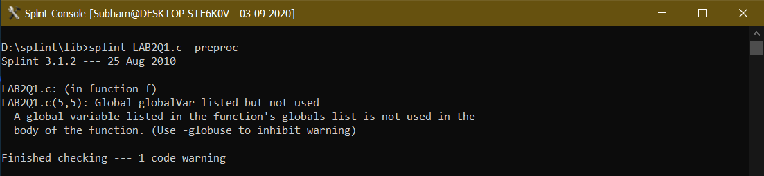

**Question 2:** Write a C program having some global variables that are declared but not initialized. Return this uninitialized variable in the main function. Run Splint for this C code and report the error generated.

**Program**:

#include <stdio.h>

int globalVar;

int main() /*@globals undef globalVar @*/

{

return globalVar;

}

**Output**:

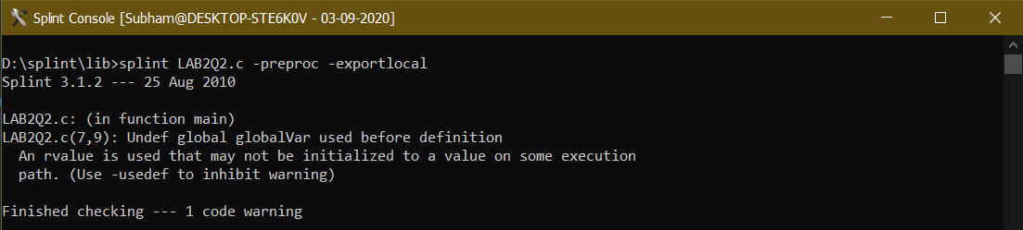

**Question 3**: Write a C program having some global variables that are declared but not initialized. Initialize some local variable using this uninitialized global variable. Run Splint for this C code and report the error generated. (For instance, assume global variable ‘a’ is declared as ‘int’ in the code. In the main function you can perform some operation such as ‘int b =a’. This code should generate some error as the variable ‘a’ is not initialized in the code.)

**Program**:

#include <stdio.h>

int globalVar;

int main() /*@globals undef globalVar @*/

{

int a;

a = globalVar;

return 0;

}

**Output**:

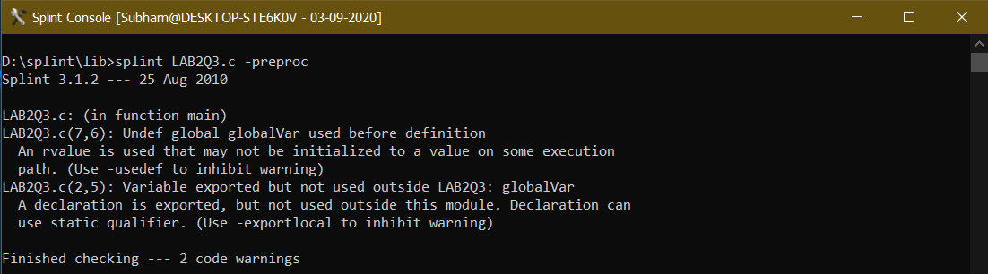

**Question 4**: Write a C program having structure as global variable. This structure can have more than two fields. Except one field, you can initialize values to all fields in the structure. Run Splint for this C code and report the error generated. (This code should generate error as you have one uninitialized field in structure)

**Program**:

#include <stdio.h>

struct Point

{

int x, y, z;

};

int main()

{

/*@ unused @*/ struct Point p1 = {.y = 0, .z = 1};

return 0;

}

**Output**:

